## Designing Interactive Reports in Power BI Desktop

**Lab Time**: 60 minutes

**Lab Folder**: C:\Student\Modules\05_Reports\Lab

**Lab Overview**: In this module you will continue to extend the Power BI Desktop project named **Wingtip Sales Analysis** that you have been with working with over the last few labs. In this lab you will focus on designing additional report pages. After creating and designing the several new report pages in the project, you will then configure security roles in the project to enable row-level security. At the end of the lab, you will publish your report and its underlying dataset to the Power BI service. This final step will allow you to see how your report looks in the browser in the Power BI service and it will also give you a chance to experience how row-level security works in Power BI.

**Lab Dependency:** This lab assumes you have completed the previous lab titled **Modeling with Dimensional Hierarchies and Time Intelligence** in which you extended the PBIX project with a calendar table and additional measures. If you would like to begin work on this lab without completing the earlier lab, copy the lab solution file named **Wingtip Sales Analysis.pbix** which is located in the student folder at **C:\Student\Modules\05_TimeIntelligence\Lab\Solution** into the folder at **C:\Student\Projects** using the Windows Explorer.

### Exercise 1: Create the Sales Revenue Breakdown Report

In this exercise you will create the **Sales Revenue Breakdown** report to design a new report page that shows how sales revenue breaks down over the last 4 years in areas such as product category, customer type, sales region and purchase type.

1. Launch Power BI Desktop.
2. Open the Power BI Desktop project named **Wingtip Sales Analysis.pbix** from the previous lab located at the following path.

C:\Student\Projects\Wingtip Sales Analysis.pbix

1. When the project opens, click the report icon on the top of the sidebar to enter report view mode.
2. Create a new report page to the project and rename it to **Sales Revenue Breakdown**.



1. Add a new visual to the report to show sales revenue broken down by product category.
   1. Make sure the **Home** tab is active on the ribbon.
   2. Click on the **New Visual** button to add a new visual to the page.

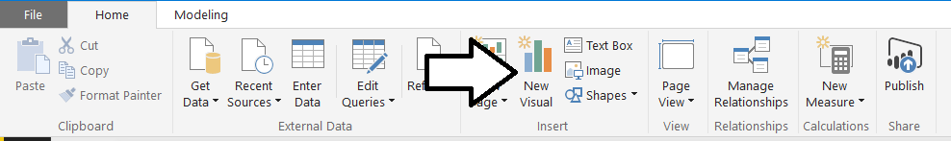

* 1. Click the **100% Stacked column chart** button in the **Visualizations** list to change the visualization type.

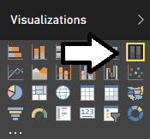

* 1. Drag the **Quarter** column from the **Calendar** table in the **Fields** list and drop it into the **Axis** well in the **Visualizations** pane.
  2. Drag the **Category** column from the **Products** table and drop it into the **Legend** well in the **Visualizations** pane.
  3. Drag the **Sales Revenue** measure from the **Sales** table and drop it into the **Value** well in the **Visualizations** pane.

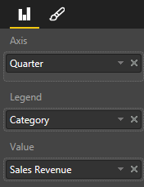

* 1. At this point, your visual should match the following screenshot.

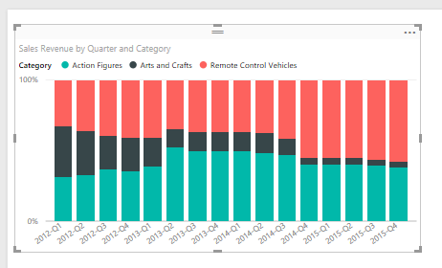

* 1. Click on the **Edit Brush** icon in the **Visualizations** pane to view the Format properties for the visual. Locate the **Border** property and change its value to **On** as shown in the following screenshot.

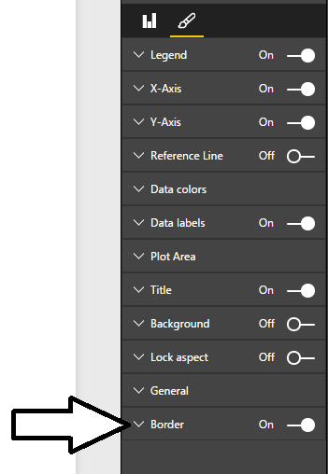

* 1. Now the visual should display with a solid border.

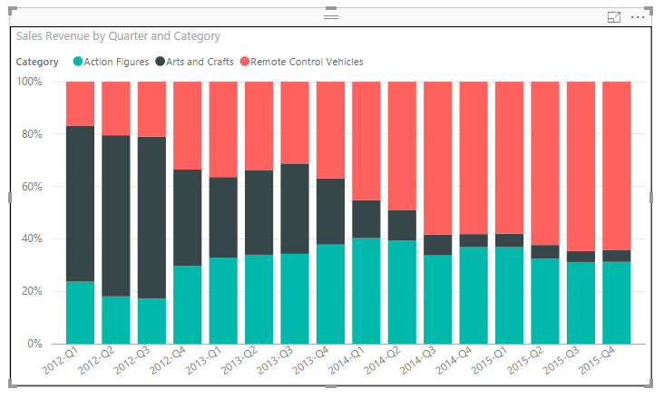

* 1. Modify the legend settings for the visual

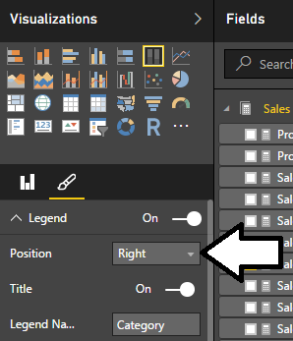

* 1. Now it should look like this.

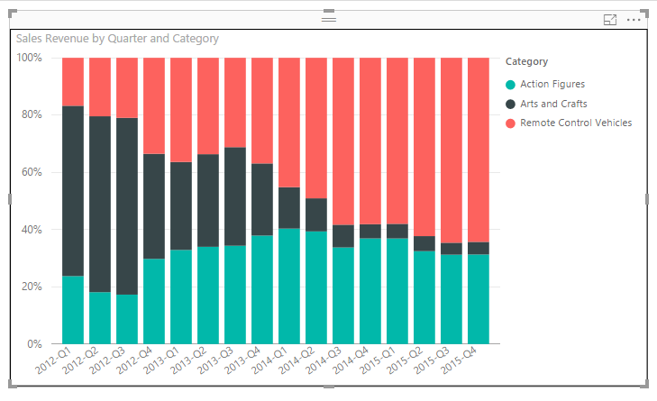

* 1. Reposition the visual so it takes up the entire upper, left-hand corner of the page.

1. Create a second visual to display a breakdown of sales revenue by customer type.
   1. Select the existing visual and copy it to the Windows clipboard.
   2. Perform a paste operation to add a second copy of the visual to the report page.
   3. Reposition the visual so it takes up the entire lower, left-hand corner of the page.
   4. Make sure the second visual is selected and examine its properties in the **Visualizations** pane.
   5. Remove the **Categories** column from the **Legend** well.
   6. Drag the **Customer Type** column from the **Customers** table and drop it into the **Legend** well in the **Visualizations** pane.

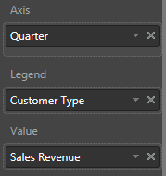

* 1. The new visual should now match the that is visual shown in the following screenshot.

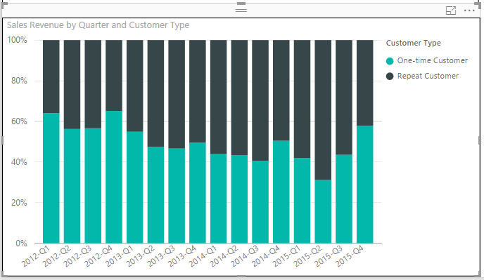

1. Create a third visual to display a breakdown of sales revenue by sales region.
   1. Select the first visual on the top, left of the page and copy it to the Windows clipboard.
   2. Perform a paste operation to add a new copy of the visual to the report page.
   3. Reposition the visual so it takes up the entire upper, right-hand corner of the page.
   4. Make sure the third visual is selected and examine its properties in the **Visualizations** pane.
   5. Remove the **Categories** column from the **Legend** well.
   6. Drag the **Sales Region** column from the **Customers** table and drop it into the **Legend** well in the **Visualizations** pane.

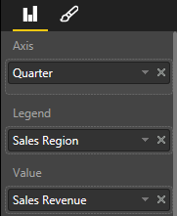

* 1. The new visual should now match the visual shown in the following screenshot.

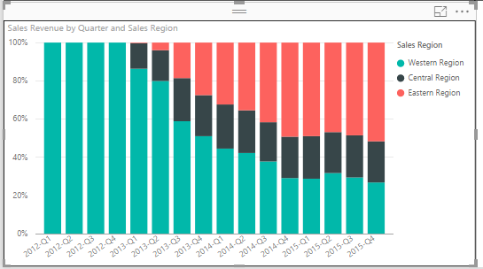

1. Create a fourth visual to display a breakdown of sales revenue by purchase type.
   1. Select the first visual on the top, left of the page and copy it to the Windows clipboard.
   2. Perform a paste operation to add a new copy of the visual to the report page.
   3. Reposition the visual so it takes up the entire lower, right-hand corner of the page.
   4. Make sure the new visual is selected and examine its properties in the **Visualizations** pane.
   5. Remove the **Categories** column from the **Legend** well.
   6. Drag the **Purchase Type** column from the **Purchases** table and drop it into the **Legend** well in the **Visualizations** pane.

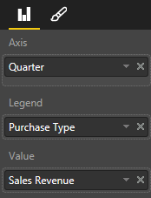

* 1. The new visual should now match the visual shown in the following screenshot.

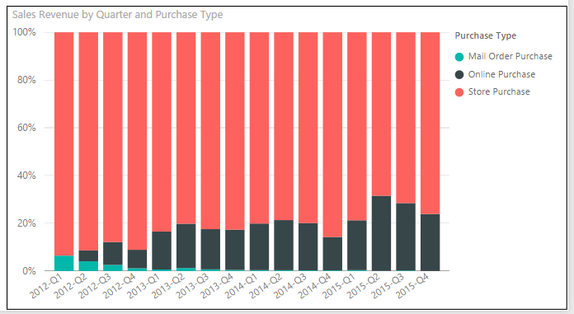

* 1. Make sure that the four visuals are laid out on the page as shown in the following screenshot.

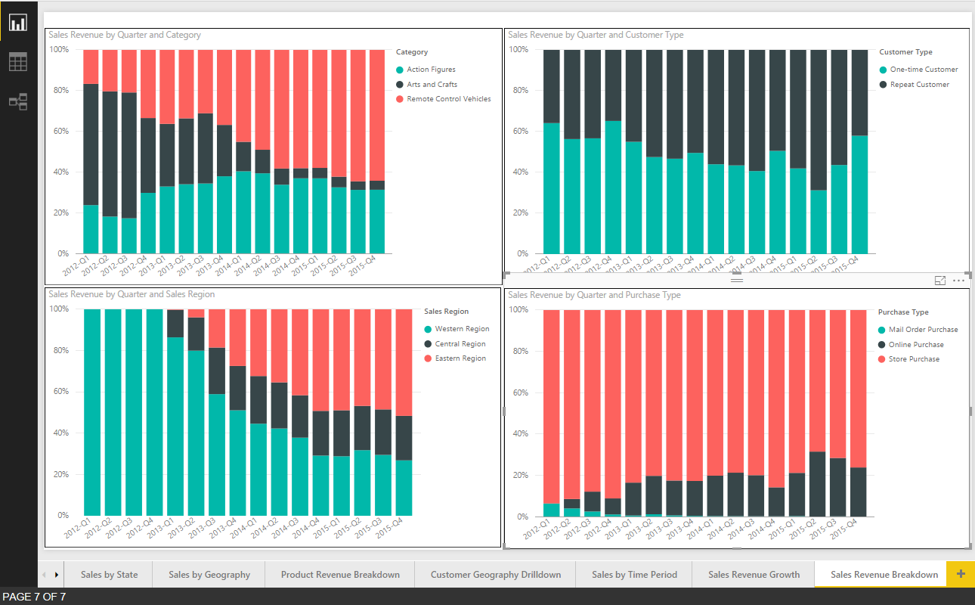

1. Save the work you have done by clicking the **Save** button in the upper left corner of the Power BI Desktop window.

### Exercise 2: Import a Custom Visual for Use in a Power BI Report

In this exercise you will download a custom visual from the Power BI custom visuals gallery and then you will import it into Power BI Desktop so you can use it in the report you have been designing. In particular, you will leverage the **Hierarchy Slicer** custom visual which provides the ability to drill down into a dimensional hierarchy such as **Product Category**.

1. Download the custom visual from the custom visuals store.
   1. On the Home tab of the ribbon, locate and click the **From Store** button in the **Custom visuals** group.

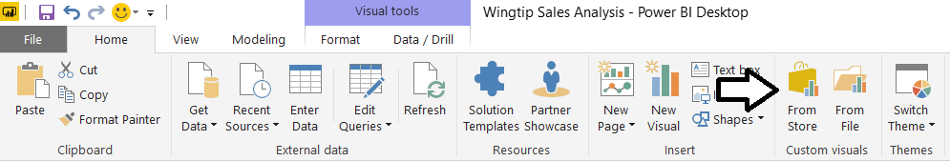

* 1. In the Custom Visual dialog, type hierarchy into the search box and click the search button.

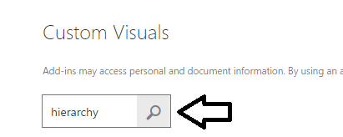

* 1. Locate the custom visual named **Hierarchy Slicer** and click **Add**.

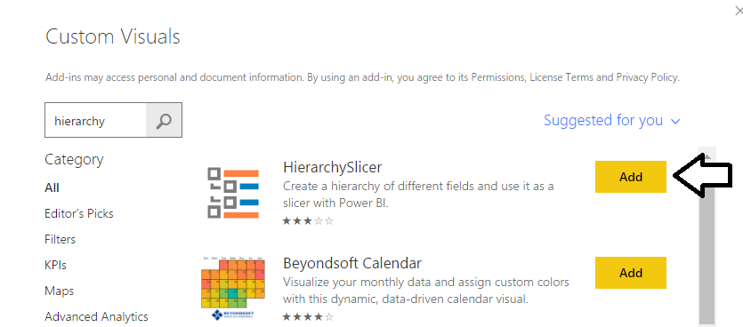

* 1. You will prompted with a dialog that informs you the visual has been imported successfully. Click **OK** to dismiss the dialog.

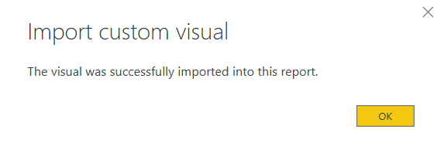

* 1. Once the custom visual has been imported, you should be able to see a new button for it in the **Visualizations** list.

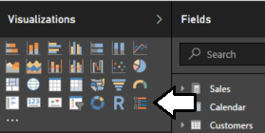

Now that you have imported the **Hierarchy Slicer** into the current project, the next step is to add this custom visual to a report.

1. Create a new report page and rename it to **Product Revenue Drilldown**.
   1. On the page navigation menu, click the (**+**) button to create a new report page.
   2. Rename the page to **Product Revenue Drilldown**.



* 1. Using the mouse, drag and drop the tab for the **Product Revenue Drilldown** page so it appears as the first page in the report.



1. Create a rectangle shape to provide background formatting for the report page.
   1. Drop down the **Shapes** menu and select the **Rectangle** command to add a new shape to the report.

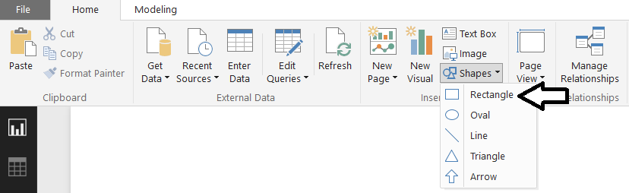

* 1. Using the mouse, resize the rectangle share to take up the full height of the report page and about 25% of the width.

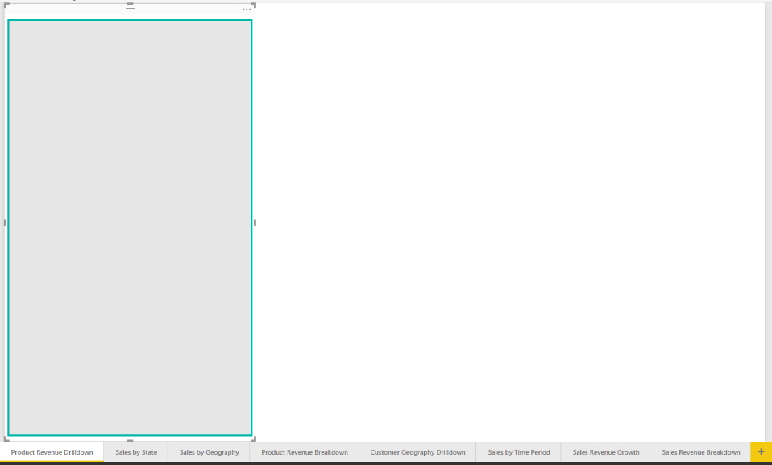

1. Create a new instance of the **Hierarchy Slicer** visual.
   1. Click the new button for the **Hierarchy Slicer** in the **Visualizations** list to create a new instance.

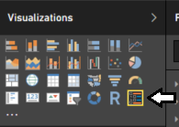

* 1. Reposition the hierarchy slicer visual inside the rectangle shape on the left side of the page.
  2. Click on the checkbox for the **Product Category** hierarchy to add it to the **Fields** well.
  3. You should now see the top-level product categories displayed in the hierarchy slicer visual.

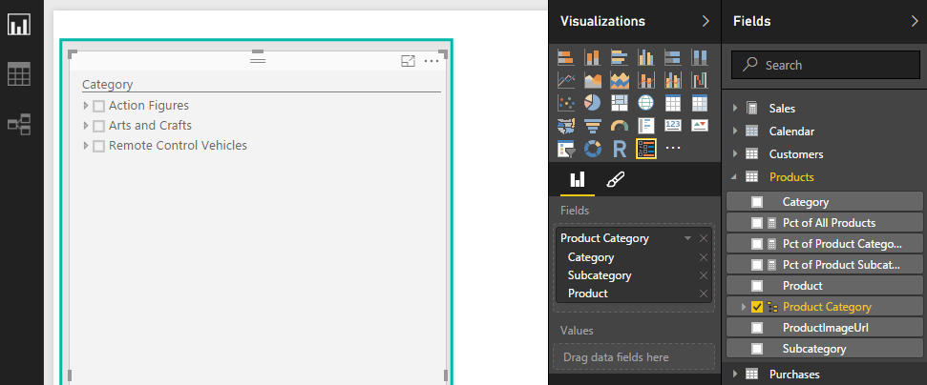

1. Create a new line chart visual to display sales revenue by sales region.
   1. Make sure the hierarchy slicer is not selected.
   2. Click on the Line chart button in the ribbon to create a new Line chart visual.

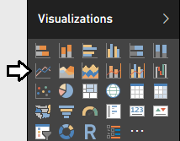

* 1. Drag and drop the **Quarter** field from the **Calendar** table into the **Axis** well.
  2. Drag and drop the **Sales Revenue** field from the **Sales** table into the **Values** well
  3. Drag and drop the **Sales Region** field from the **Customers** table into **Legend** well
  4. Reposition the visual to so it takes up all the space in the page that is not already occupied by the hierarchy slicer visual.

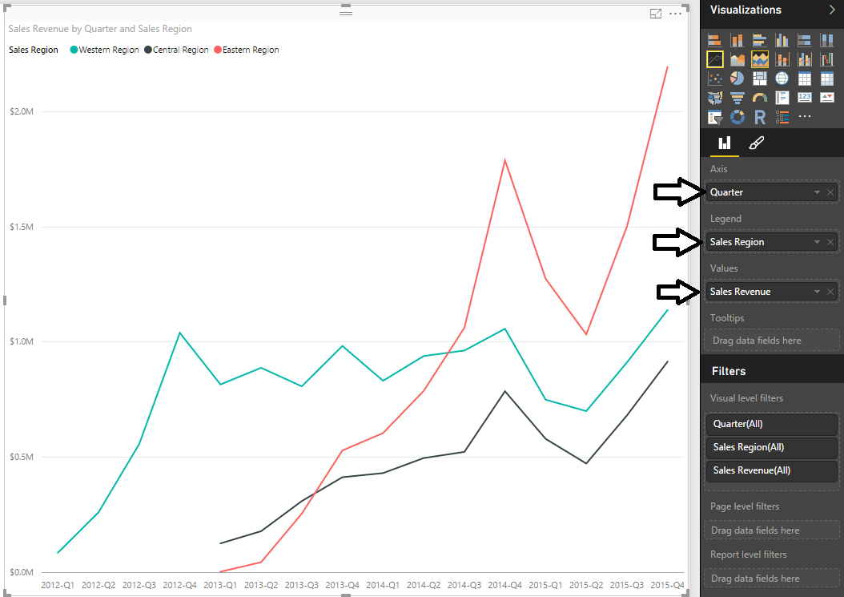

* 1. With the Line chart visual selected, navigate to the **Legend** section in the **Format** properties pane. Update the value of the **Position** property for the legend to **Bottom Centered**.

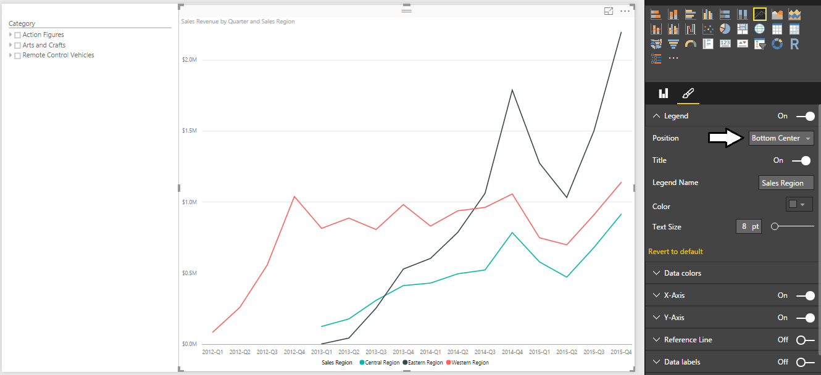

* 1. Locate the **Border** property at the bottom of the Format properties pane and set its value to **On**.

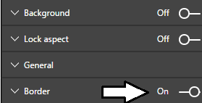

Now you have done all the work to create an interactive report page. Now it’s time to test it out and see how it helps to analyze data.

1. Use the hierarchy slicer to analyze and drill down into sales data.
   1. Experiment by selecting nodes within the hierarchy slicer.
   2. For example, select the node at **Remote Control Vehicles > Cars**.

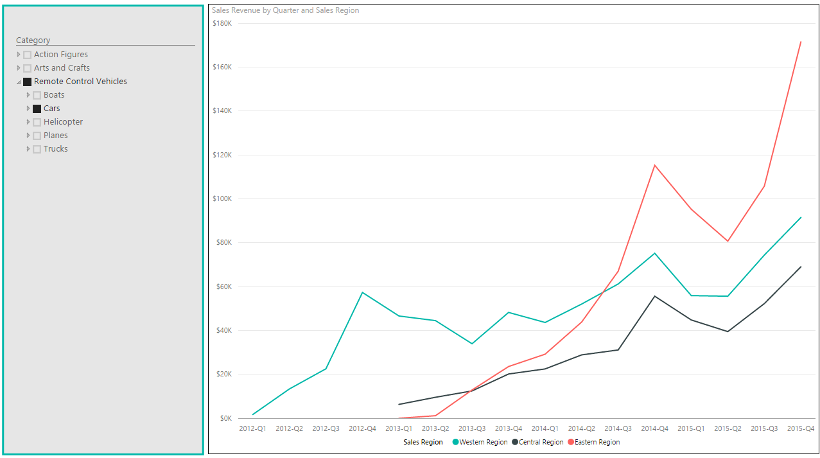

* 1. Inspect how sales compare between the categories of **Action Figures**, **Arts and Crafts** and **Remote Control Vehicles**.
  2. Drill down to the product level to inspect the month-to-month sales of individual products.
  3. Determine which products have been trending downwards in sales revenue over the last two years.

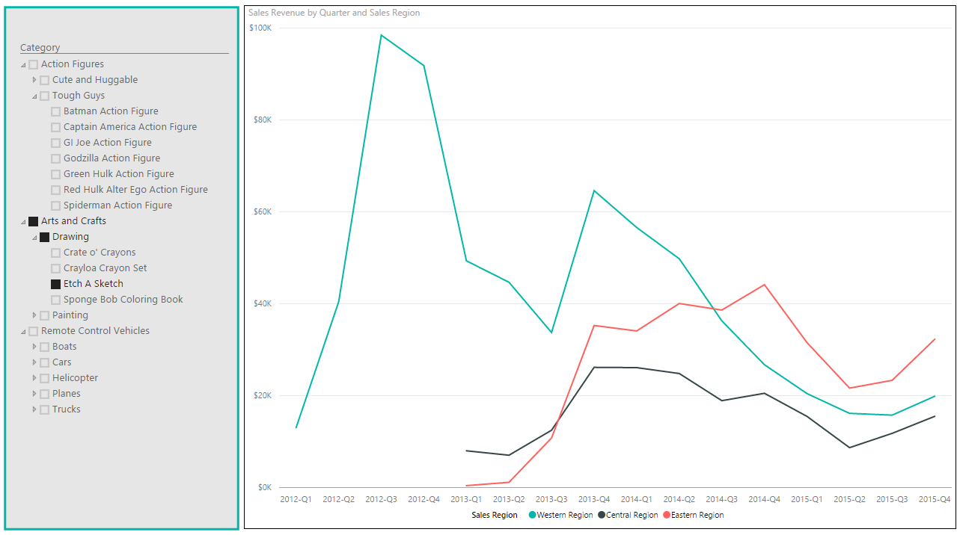

1. Save the work you have done by clicking the Save button in the upper left corner of the Power BI Desktop window.

### Exercise 3: Create the Top 5 Products Report

In this exercise you will create a measure named **Product Rank** that ranks products according to their total sales revenue. You will then work to create a report that displays the top 5 selling products. Along the way, you will design this report to be interactive allowing the user to filter on a specific year and/or a specific product category to see what products are the best sellers.

1. Create a new measure named **Product Rank** to determine the top selling products.
   1. Navigate to data view.
   2. Select the **Products** table from the **Fields** list.
   3. Create a new measure by clicking the **New Measure** button in the ribbon.
   4. Enter to following DAX expression into the formula bar to create the measure named **Product Rank**.

Product Rank =

RANKX(

ALL(Products),

CALCULATE( SUM(Sales[SalesAmount]) )

)

* 1. Press the **ENTER** key to add the measure to the data model.
  2. Ensure the formatting for this measure is set to **Whole Number** as shown in the following screenshot.

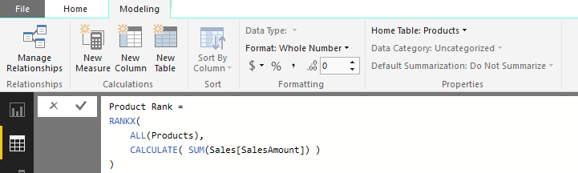

1. Create a new report page named **Top 5 Products**
   1. Navigate to report view.
   2. Create a new report page and rename it to **Top 5 Products**.
   3. Using the mouse, drag the new page tab all the way to the left so it appears first in the page navigation menu.



1. Add a new table visual to display the top 5 products.
   1. Click the **New Visual** button on the ribbon to add a new visual to the page.
   2. Change the visual to a table by clicking the **Table** button in the **Visualizations** list.

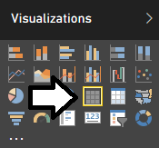

* 1. Drag and drop the **Product Rank** measure from the **Products** table into the **Values** well.
  2. Drag and drop the **Product** column from the **Products** table into the **Rows** well.
  3. Drag and drop the **Sales Revenue** measure from the **Sales** table into the **Rows** well.

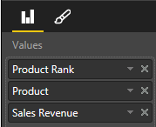

* 1. The new visual should now match the visual shown in the following screenshot.

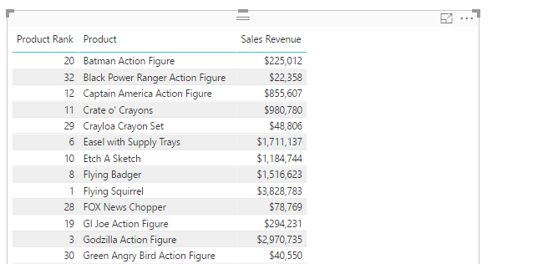

* 1. Click on the **Product Rank** column header twice to sort the visual so the products with the lowest ranks are sorted to the top.

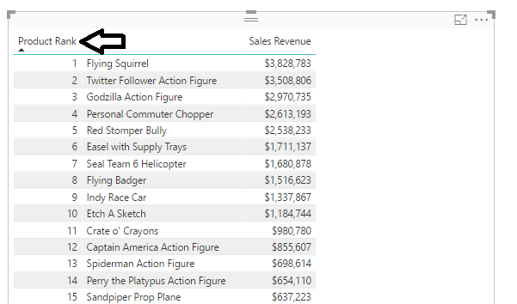

* 1. Inspect the **Visual level filters** well of the **Filters** section of the Field properties pane and locate **Product Rank**.
  2. Configure the **Product Rank** filter to only display products with a rank of 5 or lower as shown in the following screenshot and then click the **Apply Filter** link to apply the filter to the visual.

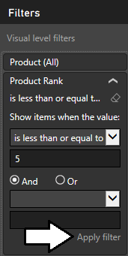

* 1. Your visual should now display the top 5 selling products as shown in the following screenshot. You should be able to observe that the visual is displaying the **Totals** row at the bottom which needs to be removed.

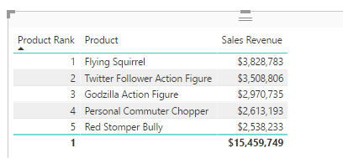

* 1. Locate the **Totals** property for the table visual in the **General** section of the property sheet and set its value to **Off**.

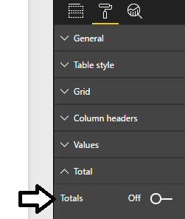

* 1. Your top 5 products visual should now look better when it is displayed without the **Totals** row.

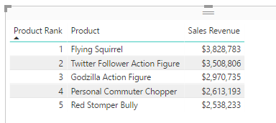

1. Create a rectangle shape to provide background formatting for the report page.
   1. Drop down the **Shapes** menu and select the **Rectangle** command to add a new shape to the report.
   2. Using the mouse, resize the rectangle share to take up the full height of the report page and about 25% of the width.

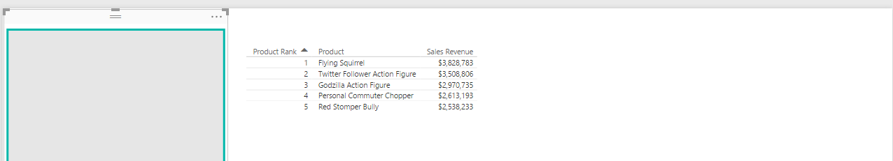

1. Add a new slicer visual to the page to filter the top 5 products visual by **Year**.
   1. Click the **New Visual** button on the ribbon to add a new visual to the page.
   2. Change the visual to a slicer by clicking the Slicer button in the **Visualizations** list.

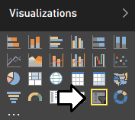

* 1. Position the slicer on top of the rectangle.

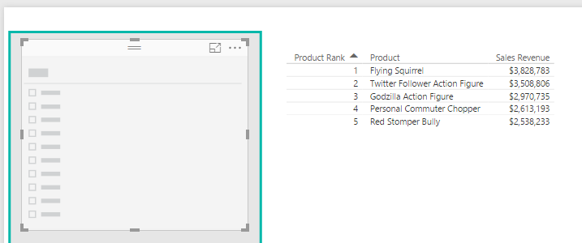

* 1. Drag and drop the **Year** column from the **Sales** table into the **Values** well.

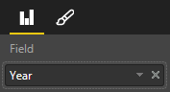

* 1. You should now have a slicer visual on the page that is configured as a list as shown in the following screenshot

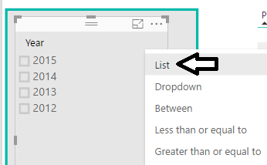

* 1. Reposition the two visuals on the page to match the following screenshot.

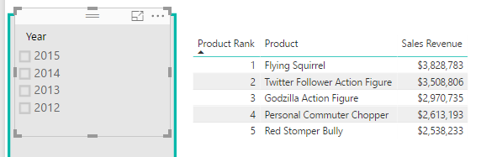

* 1. Experiment using the **Year** slicer by selecting individual years. You should see that the top 5 products visual updates whenever you select a different year.

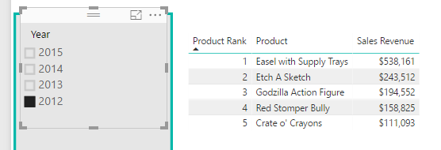

1. Add a second slicer visual to the **Top 5 Products** page to filter by **Category**.
   1. Click the **New Visual** button on the ribbon to add a new visual to the page.
   2. Change the visual to a slicer by clicking the Slicer button in the **Visualizations** list.
   3. Drag and drop the **Category** column from the **Products** table into the **Values** well.

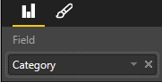

* 1. Reposition the new visual to match the page layout shown in the following screenshot.

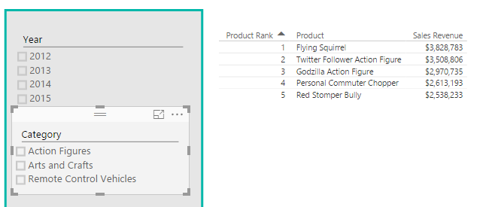

* 1. Experiment using the **Category** slicer by selecting individual product categories. You should see that there is now a problem with the report because the visual with the top 5 products doesn’t show 5 products.

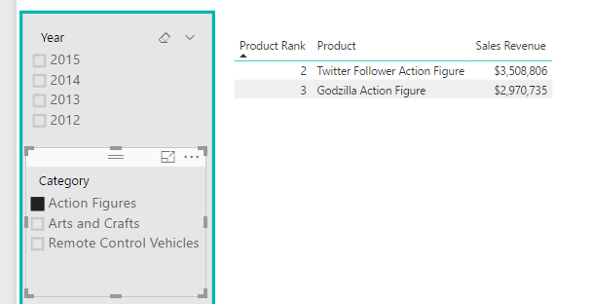

The problem you are facing here has to do with the manner in which the **Product Rank** measure is filtering during its evaluation. The problem is that the measure does not correctly filter by the product category column when determining the top 5 products. Therefore, you must modify the DAX expression for the **Product Rank** measure in order to calculate the top 5 selling products within a specific category when that category is selected in the slicer.

1. Modify the DAX expressions for the **Product Rank** measure to correct the filter problem with product category.
   1. Navigate to data view.
   2. Expand the **Products** table from the **Fields** list.
   3. Select the **Product Rank** measure in the **Products** table so you can view and modify its DAX expression in the formula bar.
   4. Modify the DAX expression for the **Product Rank** measure to match the following code listing.

Product Rank =

IF(

HASONEVALUE(Products[Product]),

RANKX(

ALL( Products[Subcategory], Products[Product] ),

CALCULATE( SUM(Sales[SalesAmount]) )

)

)

1. Test the changes you made to the **Product Rank** measure.
   1. Navigate to report view.
   2. Test the measure by selecting different categories using the **Category** slicer. At this point, the page filtering should be working correctly as you should see 5 top products when selecting a product category.

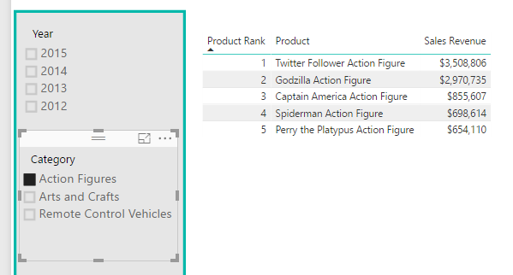

1. Add support the data model to provide a product image into the report.
   1. Navigate to Data View and then inspect the fields inside the **Products** table.
   2. Right-click on the **ProductImageUrl** field and select the **Rename** command.

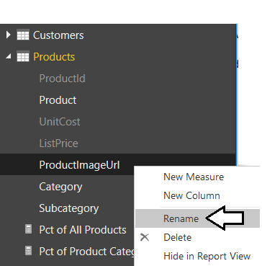

* 1. Rename the field to the more user-friendly name of **Product Image**.

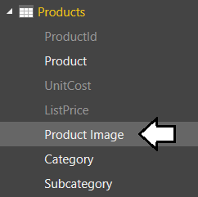

* 1. Make sure you have the **Product Image** field selected in the **Fields** list.
  2. Navigate to the **Modeling** tab in the ribbon.
  3. Drop down the **Data Category** dropdown menu and select **Image URL**.

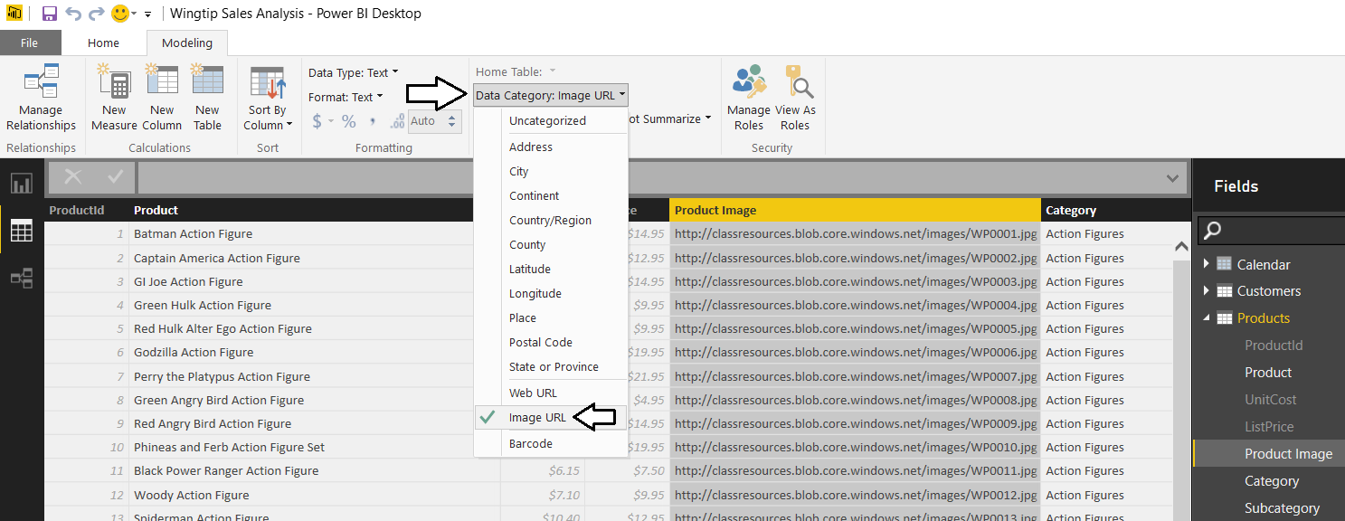

1. Add the product image to the report.
   1. Return to report view.
   2. Make sure the table visual is selected.
   3. Drag and drop the **Product Image** field from the **Products** table into the **Values** well. When you add the **Product Image** field in the **Values** well, place it in between the **Product** field and the **Sales Revenue** field as shown in the following screenshot.

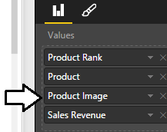

* 1. When you see the effects your change has made to the visual, you will notice there’s a problem. Every single product has a rank of 1. Therefore, the visual displays all 32 products instead of just 5 products which are the best sellers.

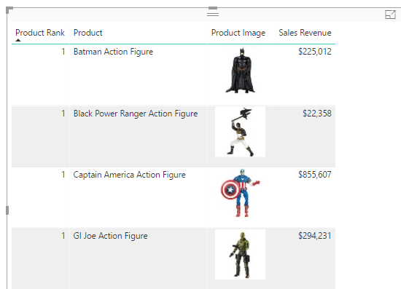

What’s the problem here? It has to do with how the **RANKX** function works when the **Product Image** field is added into the filter context for calculations inside the table visual. In particular, the **RANKX** function is calculating the ranks separately for each group of products that share the same product image. Since no two products share the same product image, each product gets a ranking of 1.

1. Modify the DAX for the **Product Rank** measure to ignore the **Product Image** field whenever it’s added to the filter context.
   1. Navigate to data view.
   2. Expand the **Products** table from the **Fields** list.
   3. Select the **Product Rank** measure in the **Products** table so you can view and modify its DAX expression in the formula bar.
   4. Modify the DAX expression for the **Product Rank** measure by adding the **Product Image** field to the call to the **All** function.

Product Rank =

IF(

HASONEVALUE(Products[Product]),

RANKX(

ALL( Products[Subcategory], Products[Product], Products[Product Image] ),

CALCULATE( SUM(Sales[SalesAmount]) )

)

)

* 1. Press Enter to save your DAX changes to the Product Rank field.

1. Return to report view
   1. You should see that now the product ranking is working the way is should.

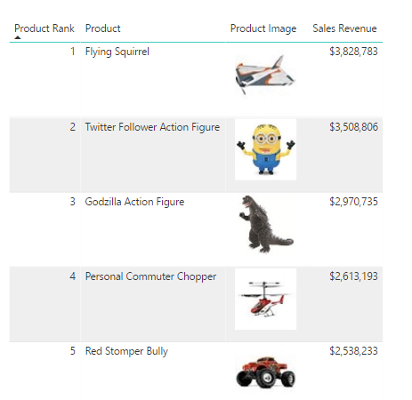

* 1. In the **Table style** section, change the **Style** to **None**.

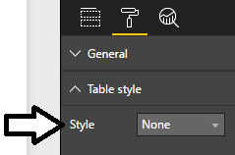

* 1. Enlarge the font size of the table visual in the **Grid** section in the Format properties pane by setting the **Text Size** to **14 pt**.

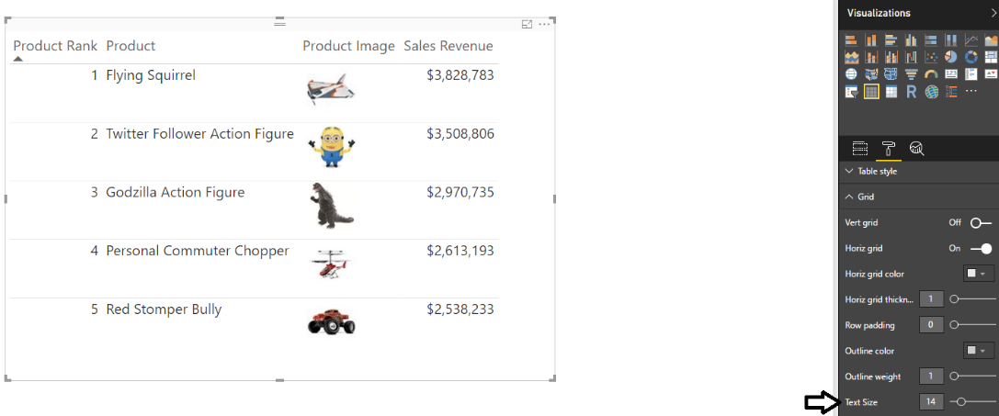

* 1. Experiment with the report interaction to drill into a year and category when determining the top 5 selling products.

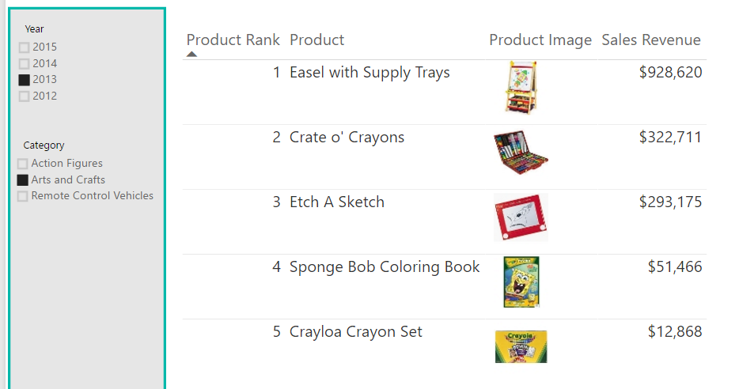

1. Save the work you have done by clicking the **Save** button in the upper left corner of the Power BI Desktop window.

### Exercise 4: Create the Top 10 Customers Report

In this exercise you will create a measure named **Customer Rank** that ranks customers according to their sales revenue. You will then work to create a report that displays the top 10 customers. You will also design this report to be interactive allowing the user to filter on a specific year or a specific sales region to see what products are the best sellers.

1. Create a new measure named **Purchase Count** to determine the number of purchases.
   1. Navigate to data view.
   2. Select the **Purchases** table from the **Fields** list.
   3. Create a new measure by clicking the **New Measure** button in the ribbon.
   4. Enter to following DAX expression into the formula bar to create the measure named **Purchase Count**.

Purchase Count = COUNTROWS(Purchases)

* 1. Press the **ENTER** key to add the measure to the data model.
  2. Ensure the formatting for this measure is set to **Whole Number** as shown in the following screenshot. Also check the comma button to format values over 1000 with a comma separator.

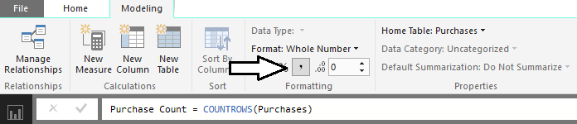

1. Create a new measure named **Customer Rank** to determine the top ranked customers with respect to sales revenue.
   1. Navigate to data view if you are not already there.
   2. Select the **Customers** table from the **Fields** list.
   3. Create a new measure by clicking the **New Measure** button in the ribbon.
   4. Enter to following DAX expression into the formula bar to create the measure named **Customer Rank**.

Customer Rank =

IF(

HASONEVALUE(Customers[Customer]),

RANKX(

ALL( Customers[Customer], Customers[Age], Customers[City], Customers[State]),

CALCULATE( SUM(Sales[SalesAmount]) )

)

)

* 1. Press the **ENTER** key to add the measure to the data model.
  2. Ensure the formatting for this measure is set to **Whole Number** as shown in the following screenshot.

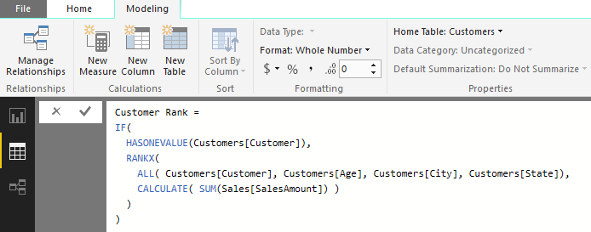

1. Create a new report page named .
   1. Navigate to report view.
   2. Create a new report page and rename it to **Top 10 Customers**.
   3. Using the mouse, drag the new page tab all the way to the left so it appears first in the page navigation menu.



1. Add a new table visual to display the top 10 customers.
   1. Click the **New Visual** button on the ribbon to add a new visual to the page.
   2. Change the visual to a table by clicking the **Table** button in the **Visualizations** list.



* 1. Drag and drop the **Customer Rank** measure from the **Customers** table into the **Values** well.
  2. Drag and drop the **Customer** column from the **Customers** table into the **Values** well.
  3. Drag and drop the **Age** column from the **Customers** table into the **Values** well.
  4. Drag and drop the **City** column from the **Customers** table into the **Values** well.
  5. Drag and drop the **Purchase Count** measure from the **Purchases** table into the **Values** well.
  6. Drag and drop the **Sales Revenue** measure from the **Sales** table into the **Values** well.
  7. Drag and drop the **Units Sold** measure from the **Sales** table into the **Values** well.
  8. The **Values** well for your visual should match the following screenshot.

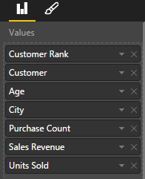

* 1. The new visual should now display as the visual shown in the following screenshot.

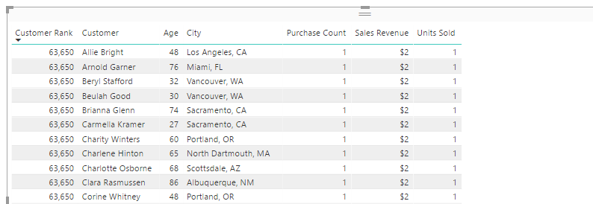

* 1. Click on the **Customer Rank** column header twice to sort the visual so the customers with the lowest rank and the greatest amount of sales revenue are sorted to the top.

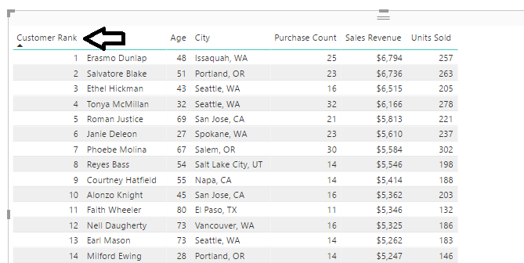

* 1. In the Field properties pane, locate the **Customer Rank** measure in **Visual level filters** well of the **Filters** section.
  2. Configure the **Customer Rank** filter to only display customers with a rank of 10 or lower as shown in the following screenshot and then click the **Apply Filter** link to apply the filter to the visual.

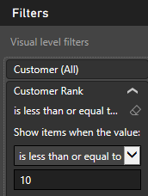

* 1. Your visual should now display the top 10 customers as shown in the following screenshot. Note that the visual is still showing the **Totals** row at the bottom which needs to be removed.

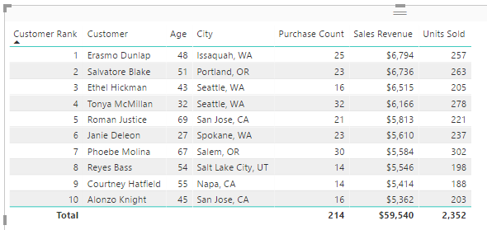

* 1. Locate the **Totals** property in the **Total** section of the property sheet for the table visual and set it to a value of **Off**.

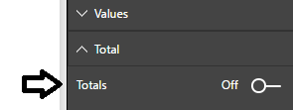

* 1. You visual should now look better when it is displayed without the **Totals** row.

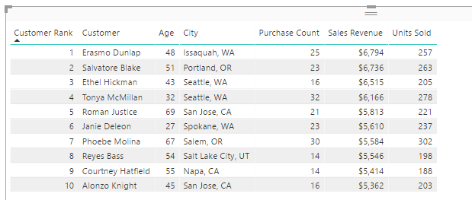

1. Create a rectangle shape to provide background formatting for the report page.
   1. Drop down the **Shapes** menu and select the **Rectangle** command to add a new shape to the report.
   2. Using the mouse, resize the rectangle share to take up the full height of the report page and about 25% of the width.

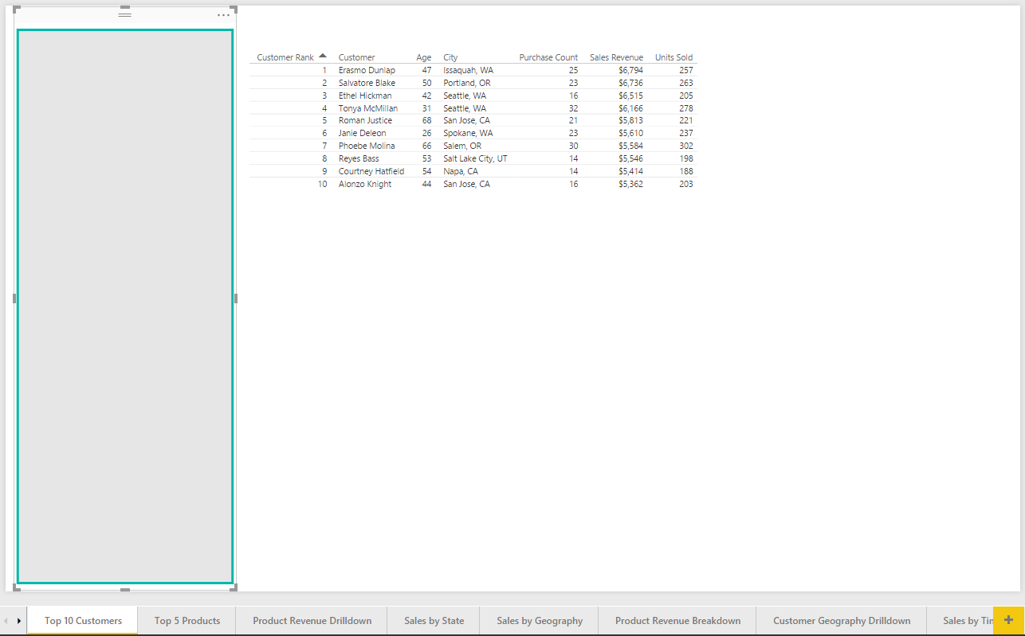

1. Add a new slicer visual to the page to filter the top 10 customers visual by **Year**.
   1. Click the **New Visual** button on the ribbon to add a new visual to the page.
   2. Change the visual to a slicer by clicking the Slicer button in the **Visualizations** list.



* 1. Drag and drop the **Year** column from the **Sales** table into the **Values** well.



* 1. You should now have a slicer visual that matches the following screenshot.

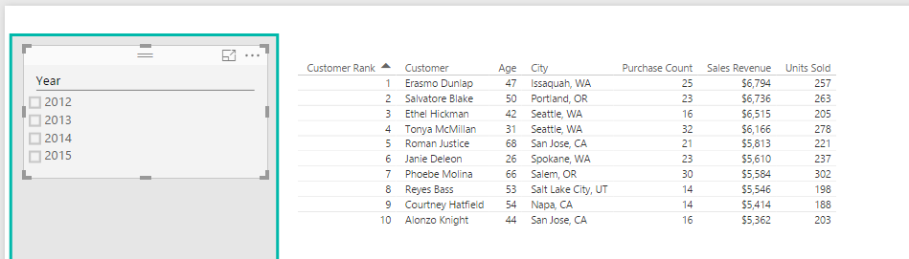

* 1. Try using the slicer by selecting individual years. You should see that the visual with the top 10 customers list changes when you select a different year.

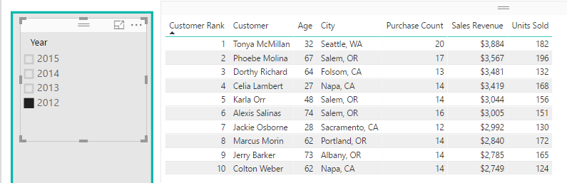

1. Add a second slicer visual to filter the top 10 customers visual by **Sales Region**.
   1. Click the **New Visual** button on the ribbon to add a new visual to the page.
   2. Change the visual to a slicer by clicking the Slicer button in the **Visualizations** list.
   3. Drag and drop the **Sales Regions** column from the **Customers** table into the **Values** well.

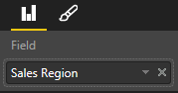

* 1. Reposition the new visual to match the page layout shown in the following screenshot.

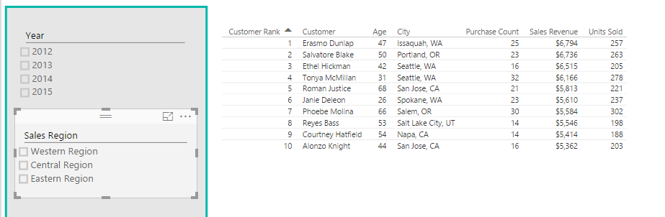

1. Add a third slicer visual to filter the top 10 customers visual by **Customer Type**.
   1. Click the **New Visual** button on the ribbon to add a new visual to the page.
   2. Change the visual to a slicer by clicking the Slicer button in the **Visualizations** list.
   3. Drag and drop the **Customer Type** column from the **Customers** table into the **Values** well.

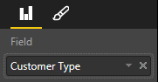

* 1. Reposition the new visual to match the page layout shown in the following screenshot.

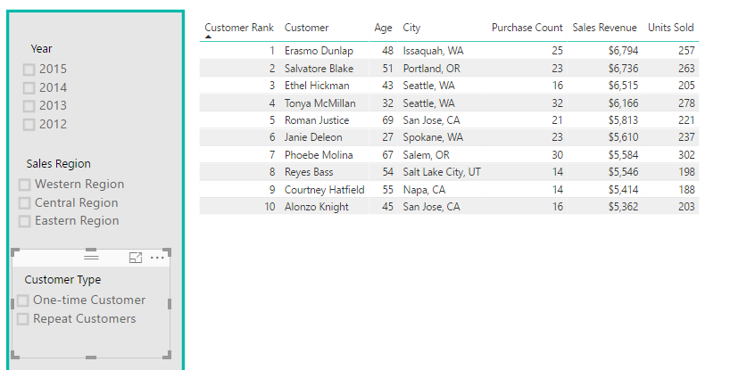

1. Add a fourth slicer visual to filter the top 10 customers visual by **Gender**.
   1. Click the **New Visual** button on the ribbon to add a new visual to the page.
   2. Change the visual to a slicer by clicking the Slicer button in the **Visualizations** list.
   3. Drag and drop the **Gender** column from the **Customers** table into the **Values** well.

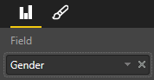

* 1. Reposition the new visual to match the page layout shown in the following screenshot.

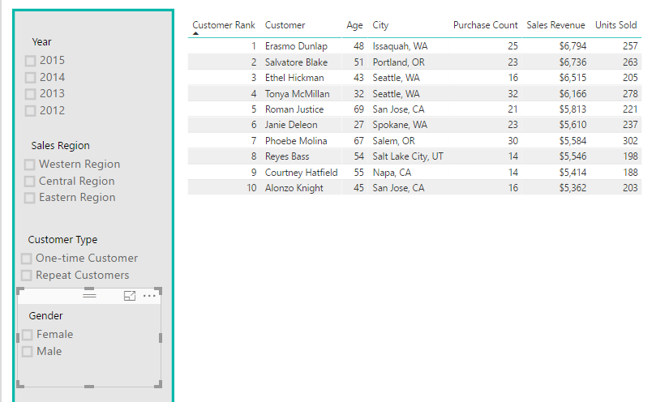

1. Now interact with the slicers on the page to answer the following questions.
   1. Who were the top 10 customers in 2013 who were repeat male customers living in the Central Region?

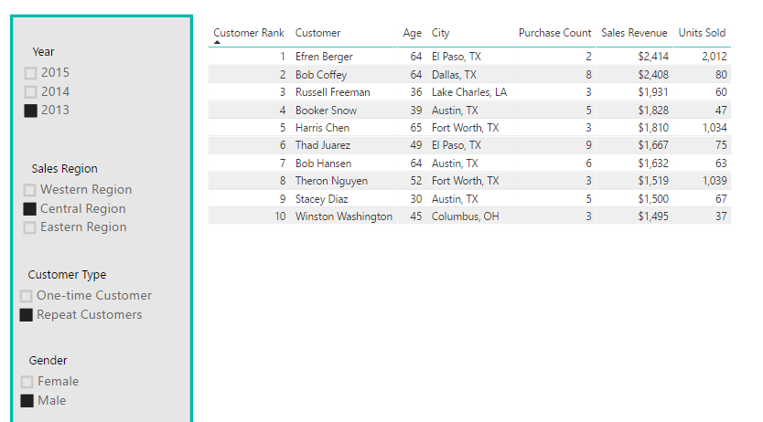

* 1. Who were the top 10 Female customers from the Eastern Region in 2015?

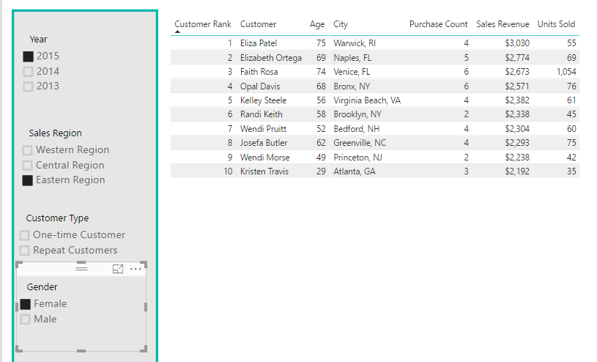

* 1. Clear the filter on all the slicers on the page so the table shows results for all sales.

1. Add a new bar chart to show the sales revenue breakdown for the top 10 customers.
   1. Change the visual to a slicer by clicking the **Stacked bar chart** button in the **Visualizations** list.

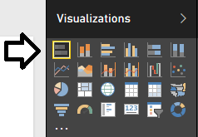

* 1. Drag and drop the **Customer** column from the **Customers** table into the **Axis** well.
  2. Drag and drop the **Sales Revenue** measure from the **Sales** table into the **Values** well.

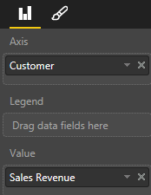

* 1. At this point, your visual should match the one shown in the following screenshot.

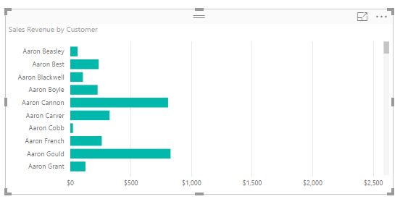

* 1. Drag and drop the **Customer Rank** measure from the **Customers** table into **Visual level filters** well of the **Filters** section.
  2. Configure the **Customer Rank** filter to only display customers with a rank of 10 or lower as shown in the following screenshot and then click the **Apply Filter** link to apply the filter to the visual.

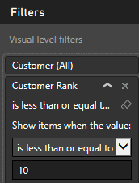

* 1. The visual should now match the following screenshot.

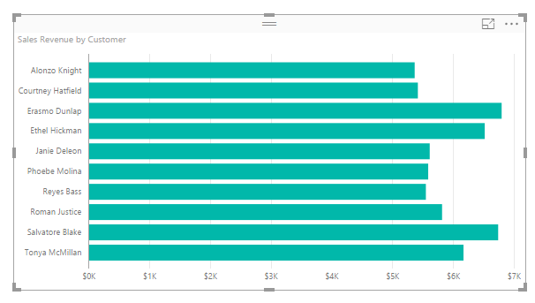

* 1. Click the ellipse (**…**) menu at the top, right corner of the visual and select **Sort By Sales Revenue** to sort the bars in the bar chart so that customers with the greatest revenue are at the top.

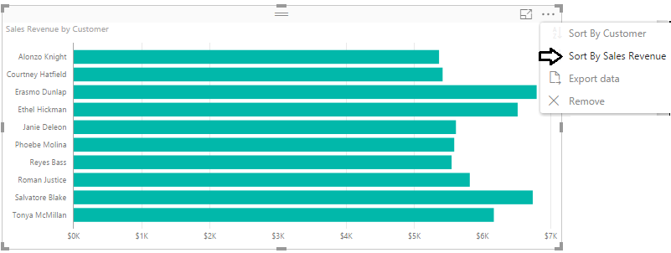

* 1. The customers in the visual should now be sorted with the greatest amounts of sales revenue at the top. Reposition the new visual to match the page layout shown in the following screenshot.

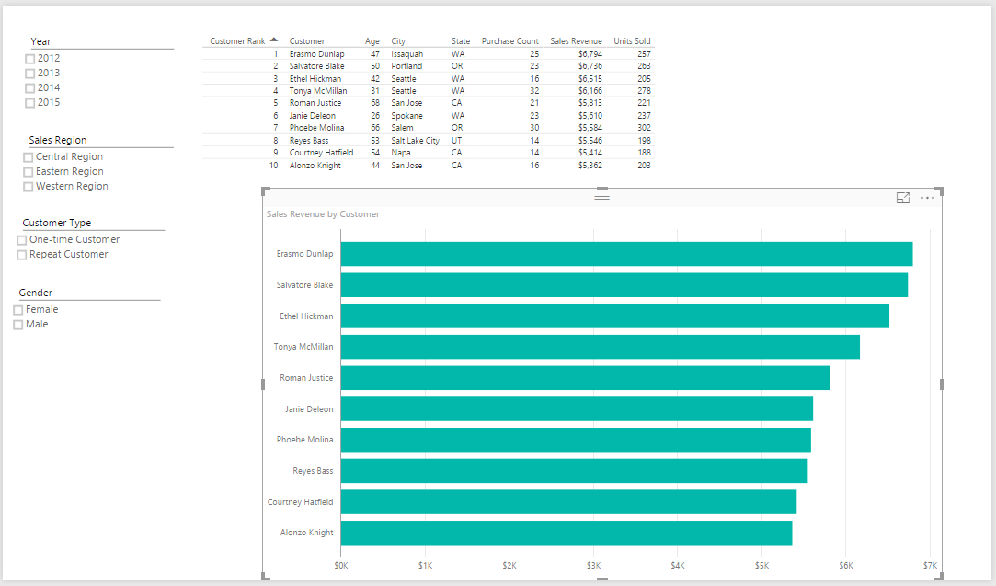

* 1. Add a small bit of formatting by selecting the bar chart and then changing the **Data labels** property setting from **Off** to **On**.

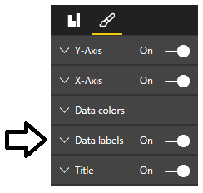

* 1. Now the visual should display an individual sales revenue total for each of the top 10 customers.

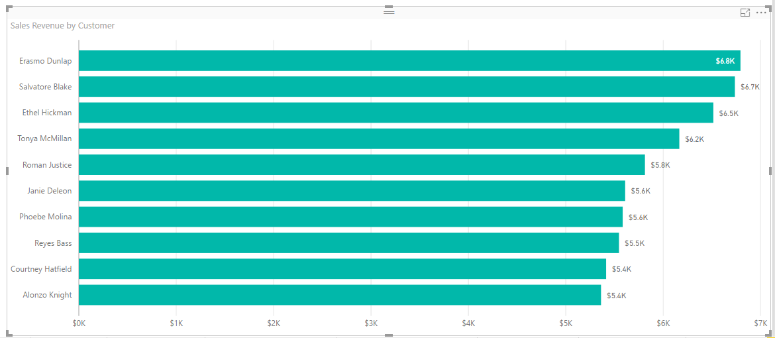

1. Test you work by using the four slicers to select different combinations of years, sales region, customer type and gender. Both the table and the bar chart with the top 10 customers should update together and stay in sync as you change the filter selection.

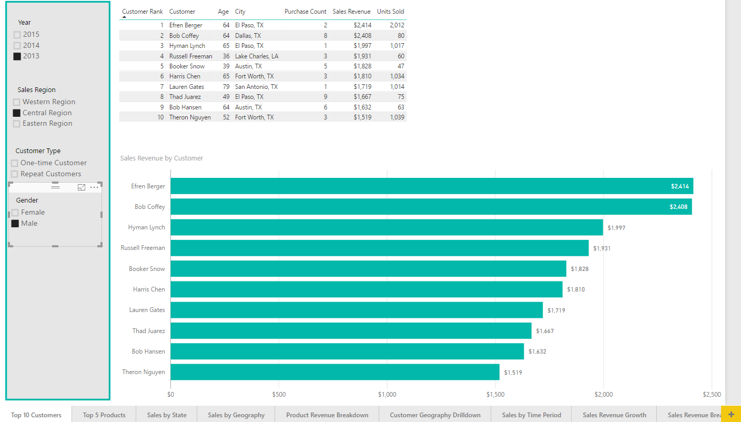

1. Save the work you have done by clicking the **Save** button in the upper left corner of the Power BI Desktop window.

### Exercise 5: Publish Your Project and Its Reports to the Power BI Service

In this exercise you will complete your work by publishing the PBIX file to your personal workspace in the Power BI service.

1. Make sure you still have the **Wingtip Sales Analysis.pbix** project file open that you created in the previous exercise.
2. Prepare the report for publishing.
   1. Navigate to report view.
   2. Click the **Top 10 Customers** page in the page navigation menu to make that the active report page.
   3. Click **Save** to save the project.
3. Publish the project to the Power BI service.
   1. Navigate to **Home** tab in ribbon
   2. Click the **Publish** button on the far right-hand side of the ribbon.

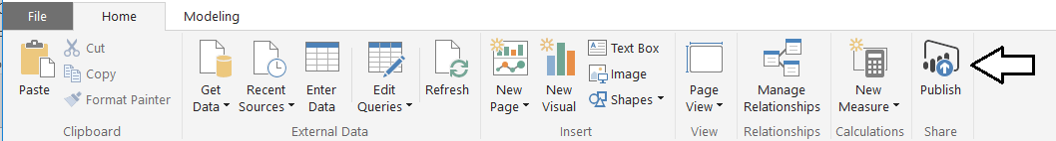

1. When promoted with the **Sign in to Power BI** dialog, click the **Sign In** button

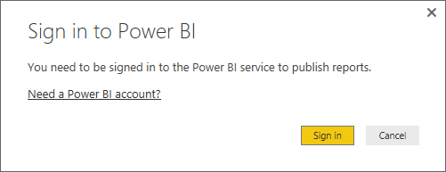

1. Sign into the Power BI service using your primary Office 365 account to give Power BI Desktop the access to publish the PBIX file.

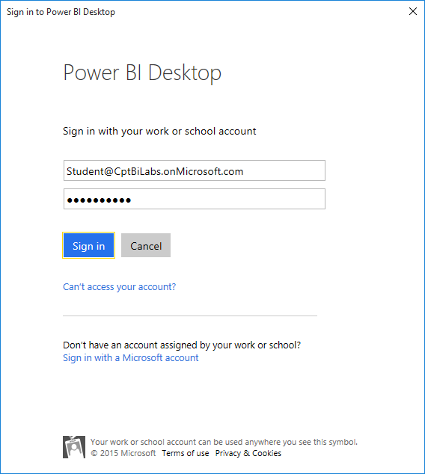

1. After you have signed in, Power BI Desktop will display the **Publishing to Power BI** dialog showing you that the publishing process is underway.

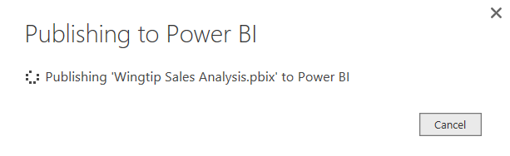

1. Once the publishing process has completed, the **Publishing to Power BI** dialog will display a success message and provide you with a link to **Open 'Wingtip Sales Analysis.pbix' in Power BI**. Click on that link to navigate to the Power BI service using the browser.

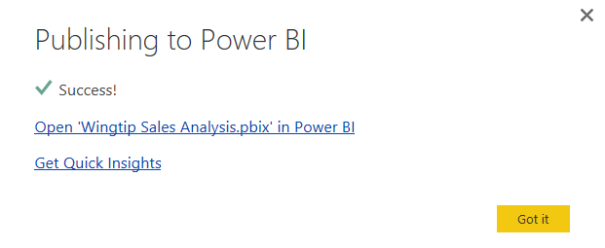

1. Once you navigate to the Power BI service in the browser, you should be able to see that the publishing process added a dataset and a report named **Wingtip Sales Analysis** that appear in the left navigation along with any other datasets and reports that were already part of your personal workspace.

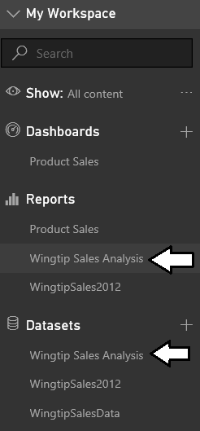

1. Inspect the various report pages that you created over the last few labs.

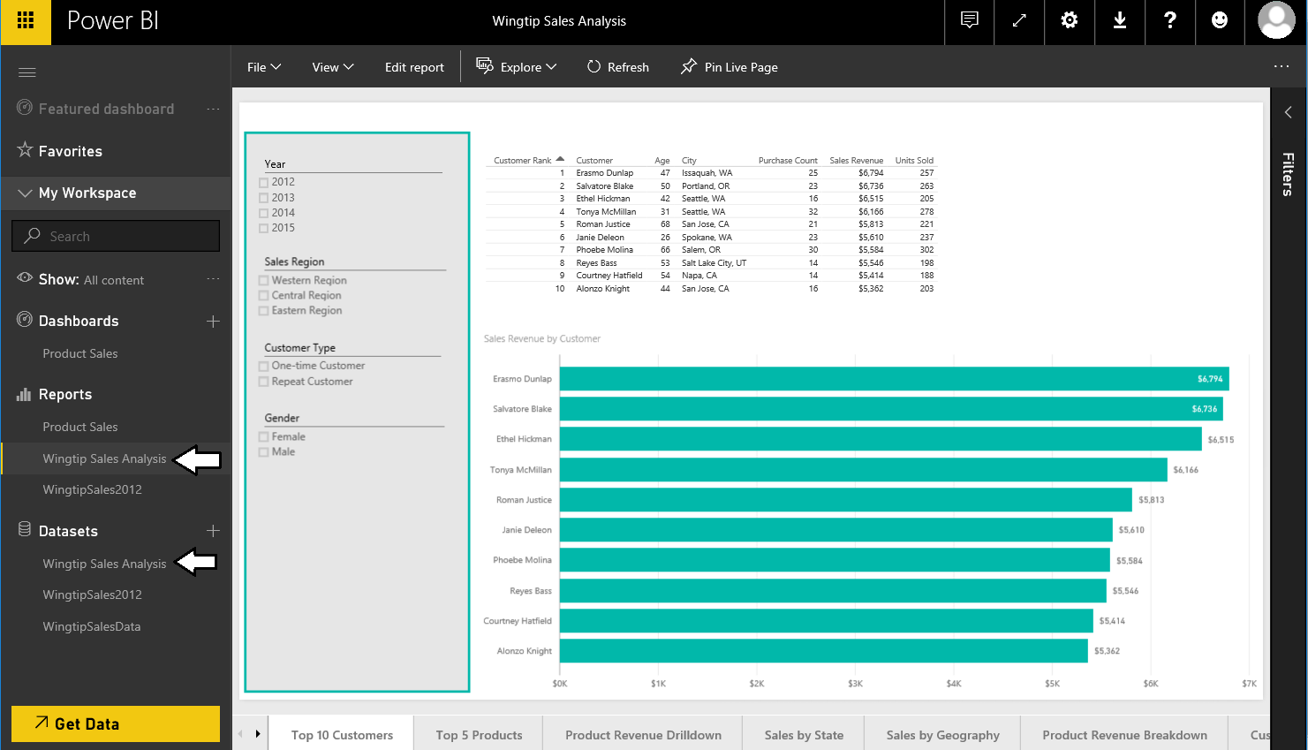

You have now successfully created and published your **Wingtip Sales Analysis.pbix** project using Power BI Desktop. In the next lab you will begin to consolidate the visuals you have created in these report pages into dashboards and you will also learn the various techniques you can use to deploy dashboards and share them with other Office 365 users using group workspaces in Power BI.